**SHIELD (Medium)**

**There's a vehicle posing as SHIELD circulating on the internet, help us identify where this vehicle is located.**

**What is the name of the app used to take this picture?**

* Right-click the image in the folder view.
* Go to “Properties.”

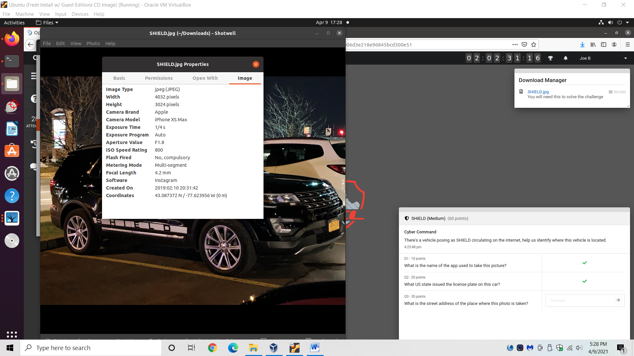

* Answer: Instagram

*Alternate approach:

* Use exiftool to display advanced metadata.
* Use *cd* command to jump to directory where the downloaded image is.
* Type *exiftool SHIELD.jpg* into the terminal.

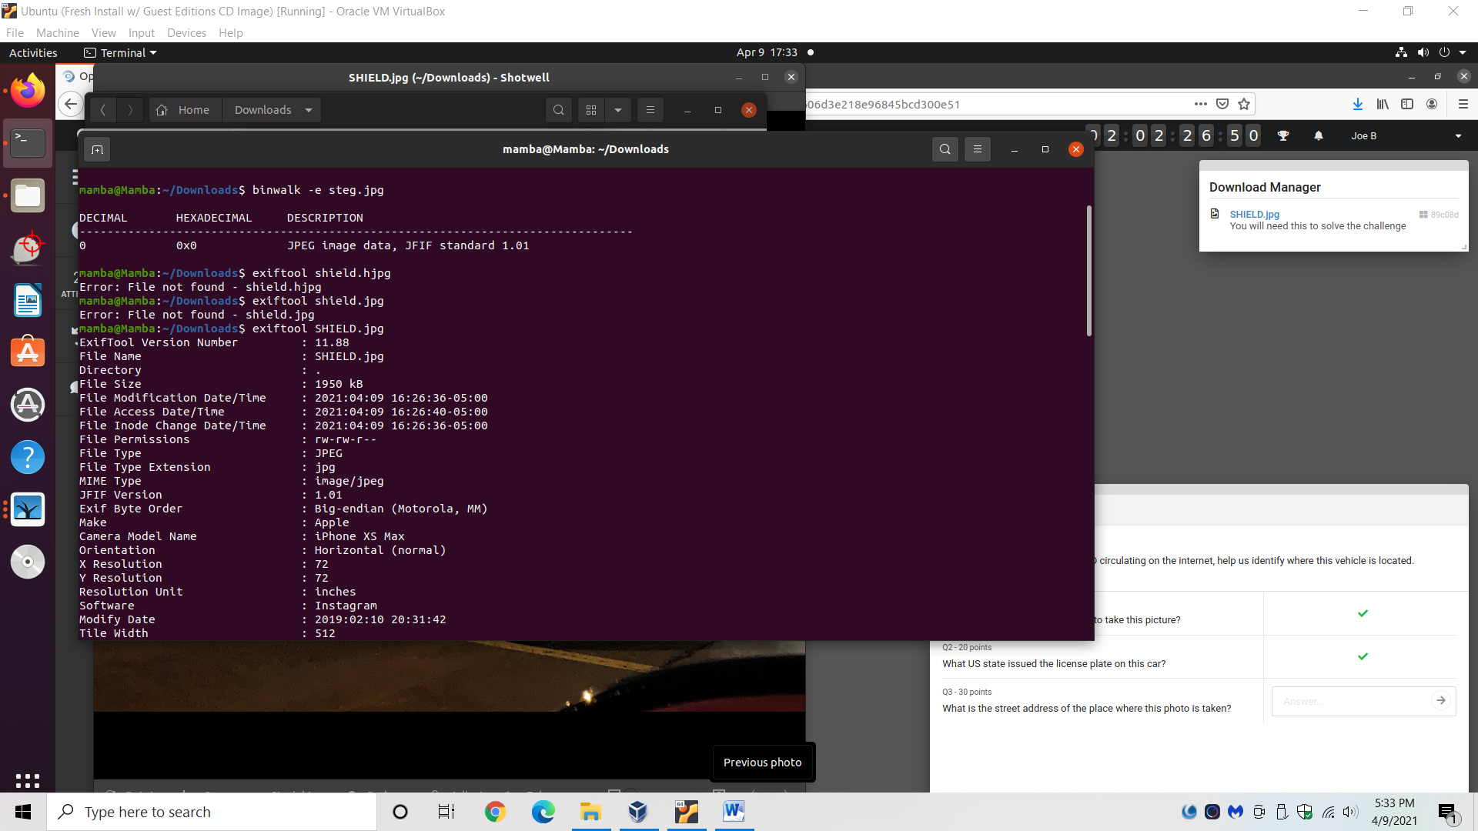

**What US state issued the license plate on this car?**

* Zoom into the image.
* Answer: New York.

**What is the street address of the place where this photo is taken?**

* Use either the right-click or exiftool method (as explained in the first question) to find the longitude and latitude coordinates of where the picture was taken.
* Go to https://www.google.com/maps
  + Make sure the coordinates are formatted in a way that Google Maps can accept.
    - Info on how to format GPS coordinates for Google Maps: <https://support.google.com/maps/answer/18539?co=GENIE.Platform%3DDesktop&hl=en-GB>
  + E.g. the coordinates as copied from exif tool are: 43 deg 5' 14.54" N 77 deg 37' 26.24" W but need to be typed out as as 43°5' 14.54"N77°37' 26.24"W for Google Maps to decipher.

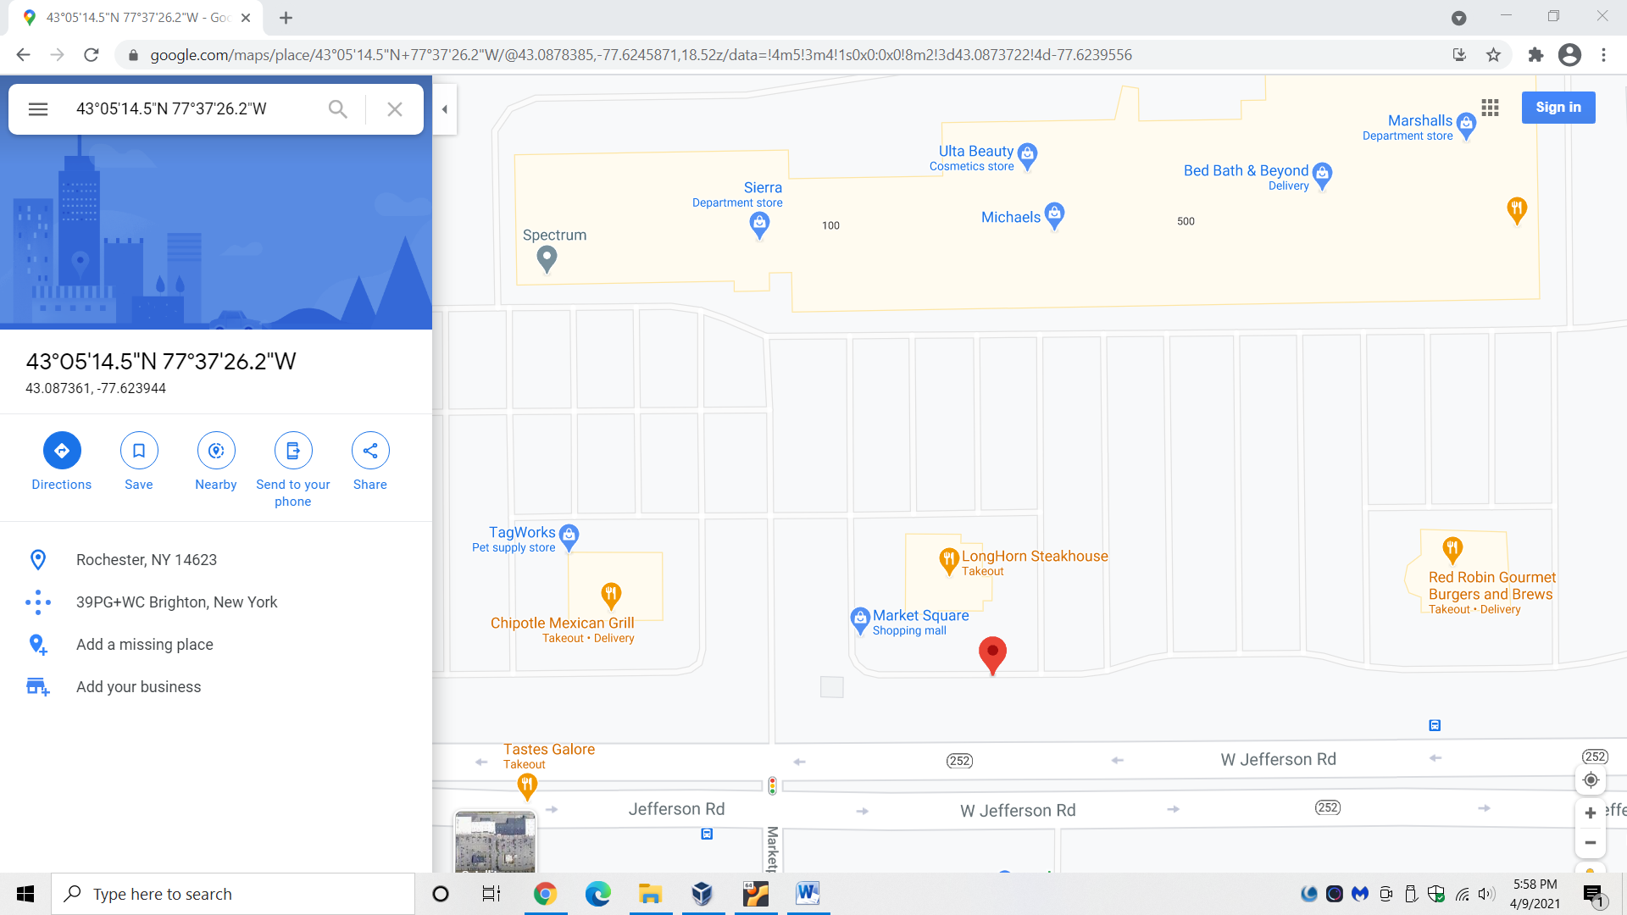

* Go to “street-view” (orange man in bottom right corner) and pan around until you see the building (LongHorn Steakhouse) where the picture was taken from.
  + Click the building to generate its address.
* Answer: 680 Jefferson Rd, Rochester, NY 14623